Networking project

The project idea given was designing a paradigm / library for distributed networks to act like the internet. Rather than having hard coded passages of data distribution, have nodes discover each other in the network similar to DNS servers looking for more servers if it did not work. Through this, by requesting how to get a task done to other nodes, you will find out the addresses of the designated nodes designed for this. This removes the necessity for large gathering centres which act as a point of failure between generated requests and actions.

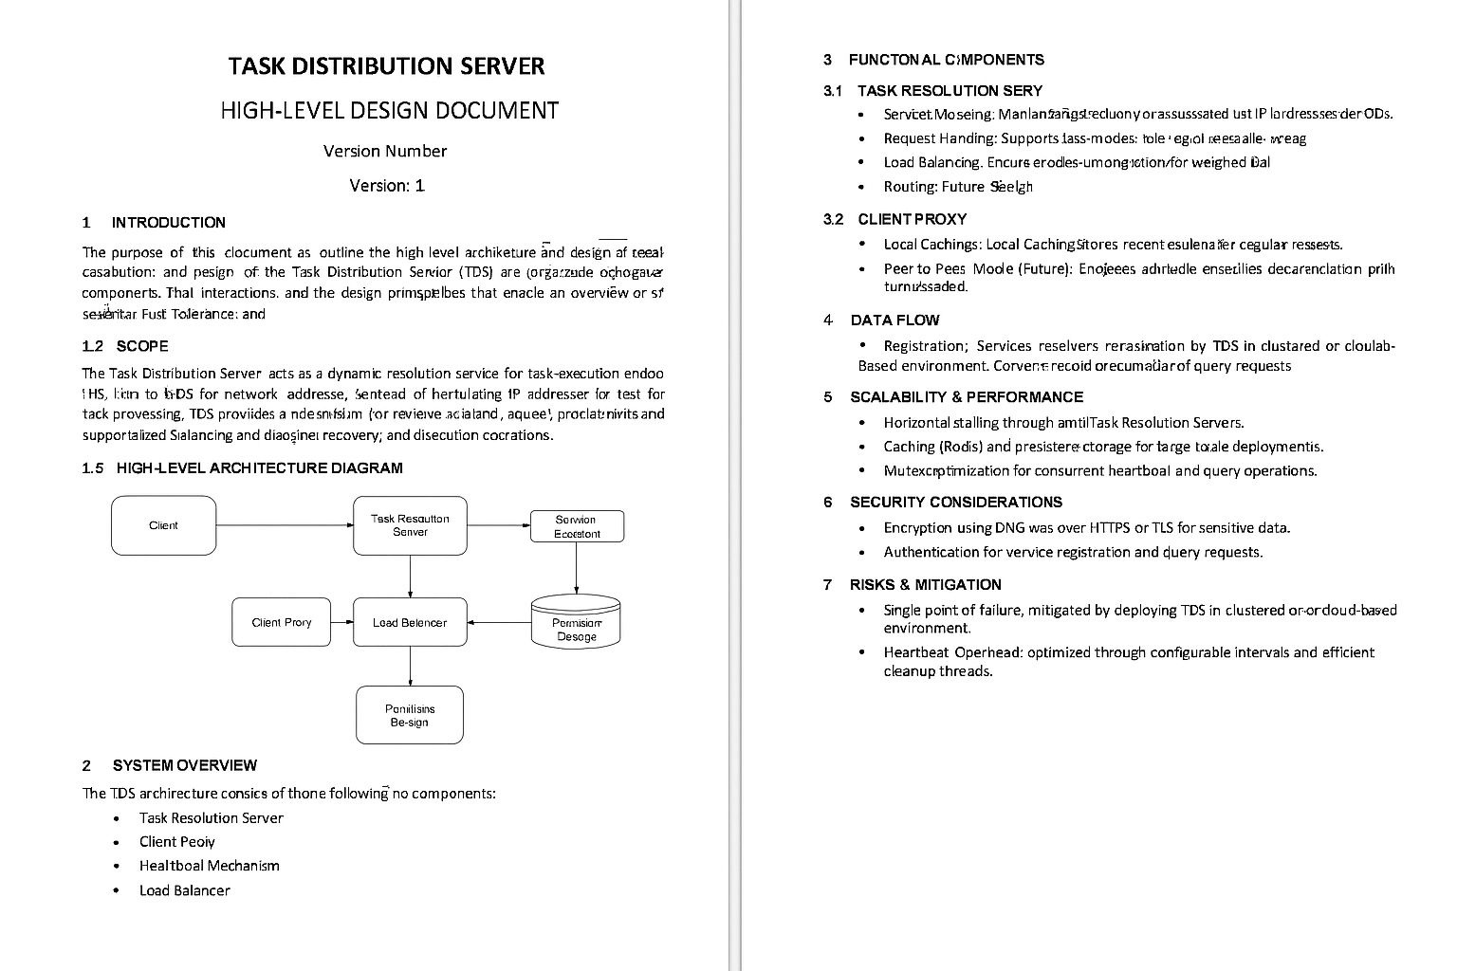
Project background

In most large-scale systems, there are entire servers dedicated exclusively to passing data processing requests to hard-coded endpoints. Not only are these servers costly and intensive but they are also a key point of failure for the system as a whole.

This project seeks to rectify this by designing and implementing a protocol library that can be added to these systems that acts similarly to DNS for the different tasks nodes in an enterprises’ system perform.

The addresses of machines and their associated task name are stored by devices in the network. When a node needs a certain task done and it does not have an associated address cached, it will send out a request to a higher device in the hierarchy (typically closer to the back office data processing centre) for addresses that match the task.

This also aids in scalability as if there is not enough throughput on a particular task a new server can be added and will send out a broadcast with its address and the tasks it performs enabling seamless horizontal scaling.

We go down two potential routes:

DNS server approach:
- Have a central set of servers that store all tasks and addresses
- Not completely decentralised but still far more versatile
- Enforces a hierarchy for search that prevents getting stuck in a circle of peers that have never completed a certain task.

Peer-to-peer approach:
- The request is broadcast and any server that has a direct answer can reply
- No reliance on central servers like DNS
- Has issues with first time task discovery
- Potentially use a task category system to widen the search if nobody has completed a certain task before they may have an address of a server that has done something in the same category

Potential uses
- Server flags as offline and all traffic is rerouted so that it can be updated

TASK DISTRIBUTION SERVER

DESIGN STUDY

Document Number: 1001 00001

Revision | Reason for change

1 Introduction
The purpose of this document is to detail the viability of the Task Distribution Server (TDS) for use in large scale systems.

Contained in this document is a justification and use case of the TDS accompanying an in-depth review of its potential functions and their advantages and disadvantages.

1.2 Scope
The role of the Task Distribution Server is similar to that of the Domain-Name-Server. Most modern IT systems are comprised of devices performing specialised tasks and passing on their data to another server for further processing. These connections, or more specifically the IP addresses of the server they pass on to, are hard coded or configured at the system level. This makes scalability and redundancy a problem as, if an extra server was introduced, all servers that feed it data must be updated involving downtime and additional testing if code changes need to be made.

My proposed solution to this is a set of servers dedicated to supplying servers that need to pass on data with the IP address of an available device that can process it. It can have many benefits including load balancing, scalability and disaster recovery. If the TDS system is placed on the cloud for example it could reroute all traffic automatically to the secondary site if there was an issue with the primary.

1.3 High Level Design Diagram

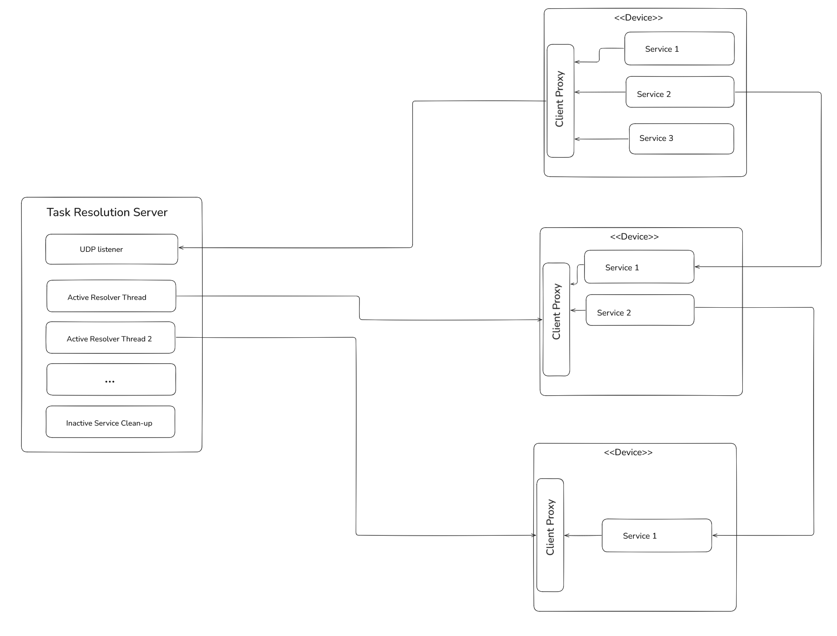
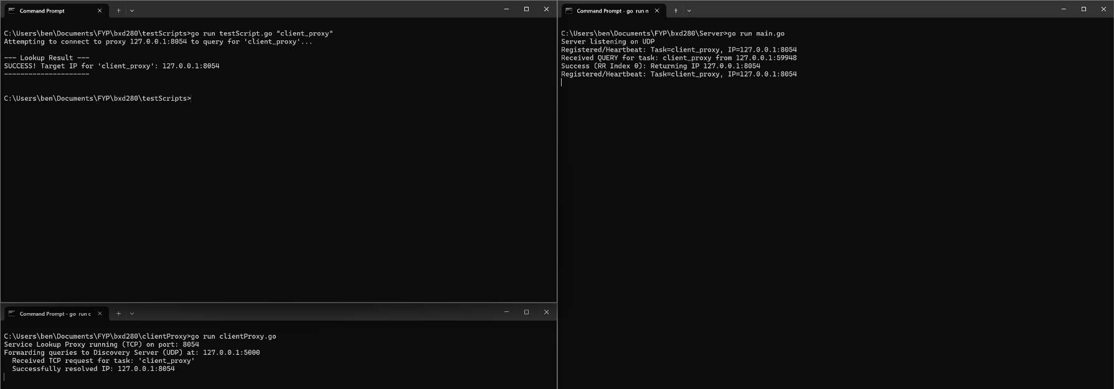

Design

Task Resolution Server Approach (current)
Services mapping: Currently a dictionary containing a task name and a list of structures containing an IP and the last time that IP checked in. This dictionary is volatile however currently due to heartbeat implementation, a server restart has minimal disruption.

Client request handler: The handler is split into two modes: task registration/heartbeat, and query resolution. Each have a separate prefix in their requests. Currently this is all completed over UDP.

Heartbeat system: The server receives regular re-registrations from services. The question is. this means that any service implemented with this architecture needs to send regular heartbeats to their proxy. A separate thread runs on the server removing any tasks that have heartbeat timestamps older than a configurable value.

Load balancing: currently the load balancing is done through round robin of each set of IP addresses for a given task.

Task Resolution Server (future)
Routing: often a machine will not be able to simply send requests straight to a service that resolves that request. This can be due to firewall rules, data environment restrictions and other issues. A proposed solution is that when services register, they provide a task category

Query efficiency: Currently the mutex for round robin and task mapping is constantly being updated by the heartbeat program. I plan to update this so that heartbeats do not lock out queries. Potentially through a separate data structure.

Load balancing: Currently done by round robin. Implementation needs updating as on the chance a selected index for round robin’s heartbeat expires, the query result returns “inactive”. This is in the event that the running cleanup does not catch and rectify the query.

Data environment separation: Create a library that allows the gateway program to advertise all the card services to a single endpoint. It would be a set of functions in clientProxy. This gateway would collect all services done on the other side and advertise them to the task Resoltion server. Potentially to stop leakage of functionality, have a “external” tag on task registration to prevent it crossing the border.

Logging and permanent storage of services: with configurations where heartbeats are less regular and in larger scale systems, the number of registered services may exceed what is reasonable to store in memory. To manage this a larger permanent database should be included along with a caching service such as Redis. This allows logging and debugging of running services and also maintains systems that have many services that are more rarely used.

Encryption of request: If sensitive information is involved in this system. Requests made to process that should be encrypted. Using either something similar to DNS over HTTP or DNS with TLS. This, if switched on, would be universal to prevent it being obvious when sensitive requests are made.

Client Proxy (current)
The client proxy runs as a separate program on the client’s computer. It receives requests from programs on that machine through a loopback port. It then forwards that request to the server and returns the response to the program that requested it.

Client proxy caching:
The client proxy holds the last 5 resolutions newer than a configured value and all registered services running on that machine. This reduces wasteful re-requests to the server and if any services are called in the same machine they do not need to request the server for it.

Client Proxy (future)
Peer to peer mode: server is removed from the architecture; client expands the cache to ten services. Every time a new service is registered it broadcasts it on the broadcast channel to other peers. Potential design with weighting.

Library implementation: The benefit of the separate proxy program is that it is universal across the machine and the caching is more powerful. However, it represents a point of failure, if there is an issue with the client proxy instance, no queries can be resolved, and the services are isolated as they cannot send heartbeats. A library instance that individual programs can use resolves this.

